Eastern State Penitentiary Project Proposal, Chris Musgrave

Summary
My project for Eastern State Penitentiary will be a multi-faceted exploration of the internal and external, as well as the physical and psychological space of this landmark architectural site. I would like to activate and transform the perception of this space by creating a light and sound piece that will be viewable during the day, in one of the cell blocks, as well as a lighting project that is viewable at night by the public, outside the gates of E.S.P. These gestures will highlight the tension between the original spiritual aspirations of the Eastern State experiment and its decline.

My proposal is separated into 2 parts. Only one of the projects could be realized, but I find that doing both would be a far more interesting statement and transformation of the E.S.P. site.

Project Narrative
PART 1:

Chromatic Wheels
Inner light (day, inside)

Chromatic Wheels is a conceptual 'gesamkunstwerk', which uses a combination of lighting gels to color the sunlight coming into the main hallway as well as the individual cell room 'eye of god' skylights.

Since this building was conceived of by Quakers to make a direct connection between spirit, light and solitude, I believe it would be interesting to work with this idea and to connect it with the other belief systems of eastern mysticism and western science.

Using the pre-existing daylight and architecture I would create a spatial experience, which relates to the Chakras of the Hindi Yoga spiritual system of subtle energies and the optical portion of the electromagnetic spectrum. By doing this, eastern and western mysticism will be conflated in space and over historical time through the application of art and science using light and sound. Each color in the Chakra system has a tone associated with it in the chromatic scale of western music. These tones would sonorously elicit, in stereo, from the cells and its corresponding color. From the end of the hallway, one would hear a chord, but by moving through the space, the tones would mix and fade as would the spectral gradations of the colored lighting. Numerically, it is also interesting to note that there are 7 cell-blocks at ESP and there are also 7 Chakras (wheels).

Another point of interest is that the indigo (third eye) Chakra relates to E.S.P., or extra-sensory perception (and intuition), which I find to be another notable connection to the initials: E.S.P. and its originally stated goals. As a final conceptual link, I would propose that this area of mysticism also crosses over well into the realm of the Ghosts, which are said to haunt these grounds.

Practical:
I would like visitors to experience this hybrid space firsthand, without explanation as to the conceptual framework behind it. Information should be administered to visitors after they had experienced the space.

The Installation would use techniques that are not destructive to the structure of the building: Lighting gels over window openings (attached lightweight fasteners) and some weather resistant consumer audio equipment. I envision using one white, well-lit cellblock (10?) for this installation. The sound can be put on timers, making it automatic.
chris@musgrave.org

PART 2:

Security
Outter light (night, outside)

Searchlights and lasers re-ignite the foreboding appearance of the Eastern State Penitentiary from the outside with its original intention to strike fear into the hearts of would be criminals in order to prevent crime. We now find ourselves in a similar situation with the war on terror, where surveillance is at an all time paranoiac high. In this light, the E.S.P. is an emblematic microcosm and precursor to the globalization of control.

The searchlights on the watchtower were a later addition to the penitentiary as it transformed from an idealistic rehabilitation penitentiary to a state of the art incarceration facility. My intent is to simply place new, high-intensity spotlights into the lamps and possibly even create a simple motorized mechanism, which would make the lights scan the grounds. Simple timers could activate them at random times, adding an element of unpredictability and surprise.

The second part of this project is to place a column of lasers into the small faux lookout slit 'windows' on the front corners of the building's towers. The lasers and lights will become more visible when there is more moisture in the air. These laser vectors will evoke images of barcode scanning, prison bars, and new biometric security devices.

Practical:
The laser key-chains I will use run off of low voltage DC current (so electrical is of little impact) and are economical at $4.95 ea. Simple wooden structures with holes drilled in them would hold the lasers in place. Nothing would be anchored into the stone. Since the lasers run from DC current, solar power with a storage battery is a likely, inexpensive maintenance/automatic solution. A timer or a light sensor will be used to cycle the power on and off.

chris@musgrave.org

Requested Funding/Budget

In order to realize this project, I would need the maximum amount of support offered by E.S.P. 1/4-1/3rd of the funding would go towards my honorarium, to support myself for the time needed to complete the project.
2/3rds of the funding would go toward supplies and labor that I cannot conduct myself, or with the staff of E.S.P.:
- Lighting filters
- Sound equipment
- Laser keychains and DC power
- Lighting for the tower and electrical contracting should power need to be installed
- Robotization of the lights.

A detailed budget shall follow if invited to participate

chris@musgrave.org

Resume / Vita / Exhibition List

Chris Musgrave, USA (b. 1969)

chris@musgrave.org
http://www.chris.musgrave.org

Formal Education

Higher Institute for Fine Art, Antwerp, Belgium

Solo Exhibitions

(2004) Grussenmeyer Gallery, Deurle, BE
(2002) University of Georgia, New Media Institute and Synergy Center, Athens, GA
(2001) 3 Walls Gallery, San Antonio, TX
(1997) The Project Room, San Antonio, TX

Group Exhibitions

(2004) Anatomy of the Now, Amsterdam
Nuit Blanche, Paris, France
RUSH, Oudenaarde, Belgium
OPEN (in conjunction with "The Big Nothing") Philadelphia, PA
Eclipse, Willebroek, BE
Open Studios, HISK, Antwerp

(2003) HOT, Tour and Taxis, Brussels, Belgium
Abstraction Now, Kunstlerhaus Wien, Austria
ENERGY, Folkwang Museum, Essen, Germany
7 ATA Festival, SF/AV, Lima, Peru
Firefly, Arts Center of the Capital Region, Troy, NY

(2002) Transcinema '02, San Jose Museum of Modern Art, San Jose, CA
Transcinema '02, The Lab, San Francisco, CA
Creacion en Movimiento, Jovenes Creadores, Mexico City
Elements of the Temporary, Southern Exposure Gallery, San Francisco, CA
Activating the Medium, California State University Chico, CA
Activating the Medium, Cuesta College of Fine Arts, San Luis Obispo, CA
Activating the Medium, Beyond Baroque Literary Arts, Venice, CA
Freebiennial, Twitch Visual, Remote Lounge, NY, NY
(2001) Untitled (Breach), Air Portugal, The Pond, San Francisco, CA
(1998) Horizons, Blue Star 13, Blue Star Art Space, San Antonio, TX
(1997) Hip Hop, The Project Room, San Antonio, TX

Performances

(2004) Factor 44, Antwerp
(2003) 7 ATA Festival, SF/AV, Lima, Peru
CalArts CEAIT Festival, Valencia, CA
(2002) Transcinema '02, 111 Minna Gallery, San Francisco, CA
(1997) The Project Room, San Antonio, TX

Screenings

(2003) Argos Festival 3, Brussels, Belgium
Triangle Project Space, San Antonio, TX
European Media Art Festival, Osnabrück, Germany
Media City, Artcite, Windsor Ontario, Canada
X-fest, Remote Lounge, New York, NY
Austin Museum of Digital Art, Digital Showcase, Austin, TX
(2002) Sightsonic, York, UK
Exploding Cinema, Seattle International Film Festival, Seattle, WA

Publications

(2004) ECLIPS Catalog
(2002) Activating the Medium, Catalog

Releases

(2004) Solo DVD release (forthcoming in 2004 on Asphodel Records)
Re-Line 2, DVD, Various artists, compilation
(2002) Wake (Loop), fiftyfifty.org loop compilation
(2002) Re-Line DVD, Various artists, compilation

Presentations

(2004) The Nordic Artists' Center in Dale, Norway
(2002) University of Georgia, New Media Institute and Synergy Center, Athens, GA
(2002) The Swiss Institute, New York, NY

chris@musgrave.org

Illustrations 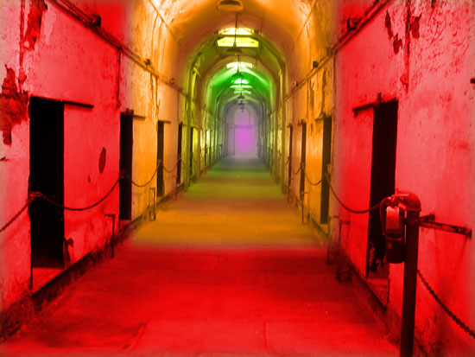
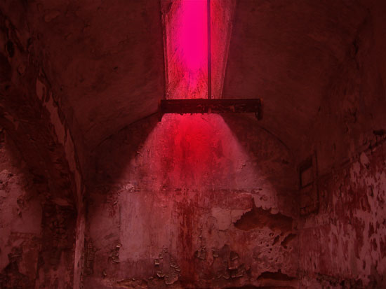
Chromatic Wheels
chris@musgrave.org

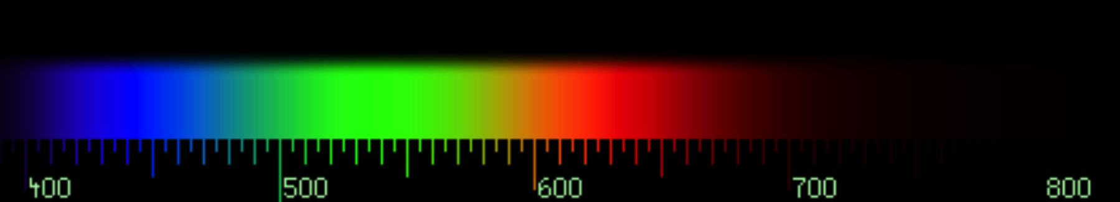
Optical spectrum and measured wavelength

Chakra colors and equivalent Musical notes

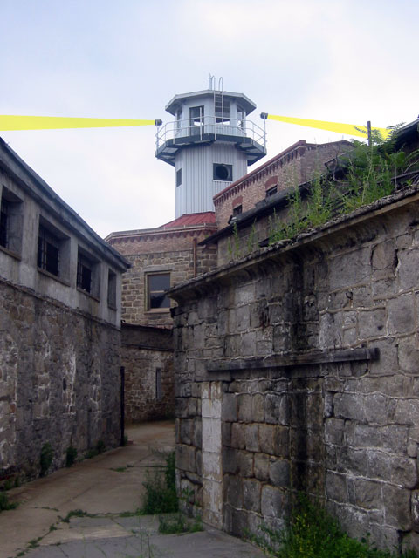 Security (guard tower)
chris@musgrave.org

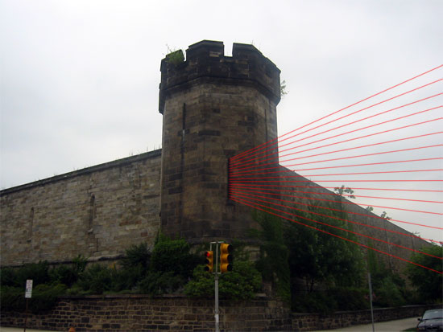
Security (beam)

Previous Work Examples
Please visit www.chris.musgrave.org to view previous work.
Due to prohibitive color reproduction costs, this document appears in black and white. This document and other support documents can be found at the following address:
www.chris.musgrave.org/projects/proposals/esp

chris@musgrave.org

